Qing Zhao

Creative Technology

23 October 2016

Reflection of Week 2

After an intensive week of learning Arduino kit, we came back to our idea proposal this week, which should be seamlessly connected with the brief “Connected Home”.

Coming up with some ideas about social connection between friends and family members, I found myself interested in the connection of across generations because I had a deep experience in communicating with my grandparents who lived in the rural country and had little access to the Internet. Personally speaking, I went to see my grandparents twice a year when I was a child, usually in summer vacation and the traditional Chinese New Year’s Festival. However, this experience seems always to be a hurry due to the limited time to share with my grandparents the whole semester’s news, which I was so excited that I couldn’t wait to tell them. It’s always the case that we ended up in a hurry and I went back to the city to take some extra lessons in my studies. As I grew up, I found my world changed a lot with the access to the Internet while my grandparents said they were abandoned by the rapidly developing technology. Although we had less common language, we love each other deeply. Every time when we say goodbye, I can see tears in their eyes, how I wish I could accompany them all year round so that they wouldn’t feel lonely anymore.

That’s why I focused on the social connection of grandparents and grandchildren, I want to minimise old people’s loneliness who live alone all year round.

I listed the facts and problems to come up with some insights of this issue and finally found the conflicts lay in the communication between technology and non-technology. To some extend, our lives are driven by the internet while our grandparents’s lives are driven by everyday routine and things they are familiar to. They may feel afraid to the newly released technology product, usually something square and with a touch screen on it. It’s in vain educating them using such kinds of technology devices because they usually don’t have good memories. It’s my opinion to utilise some low-technology but emotionally embedded in their familiar things such as tea cup, radio, kettle and so on.

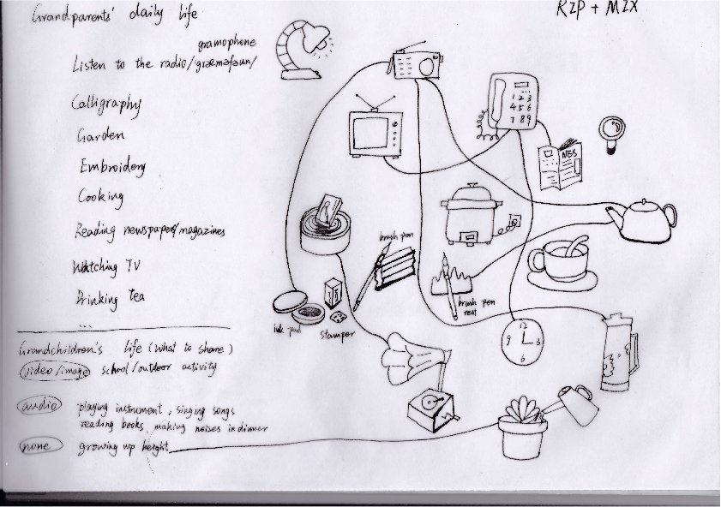

With this opinion in my mind, I listed several everyday objects which appear in high frequency in old people’s life. At the same time, I sorted the information of grandchildren that might be valuable to share with grandparents, trying to see if I could draw some connections between the objects and information. Then I did a RIP + MIX, coming up with some ideas transforming grandchildren’s video and audio information to grandparents.

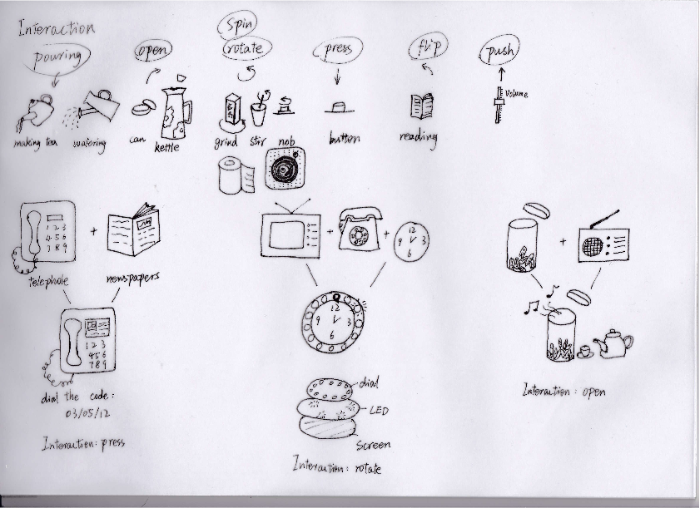

Finally, I ended up with the idea dealing with children’s growing up height and grandparent’s garden, which were very ordinary in both lives. I want to design a platform for the garden that can lift up the plant pot in correspond to the children’s height. With this platform, grandparents would feel their grandchildren’s growth in every day’s watering.

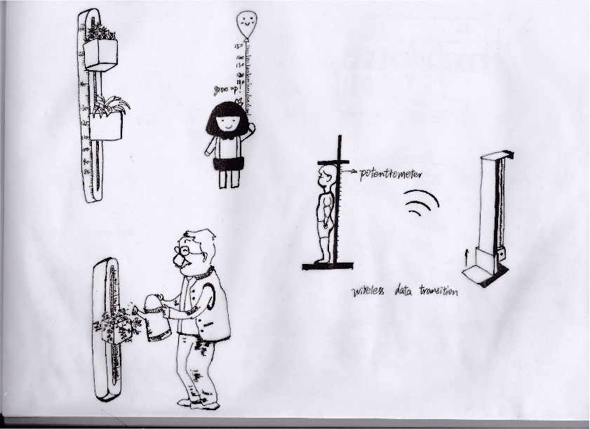

The next stage for me is to consider about the appearance of the platform and how to use Arduino to control it. Currently I am considering about using potentiometer to measure the height of the children and send the date in a wireless way to the platform, which may require an Internet environment in Grandparents’ home. Some structures are also remained to be considered in the next two weeks and I will try my best to tackle with them.